Problem Set #2
(Due: Wednesday 6/13/18 at the start of class)
Directions: Answer all of the following questions showing all of your work
APR, EAR and Continuously Compounded Interest Rates
- Here is the five-year stock chart for Amazon (AMZN).
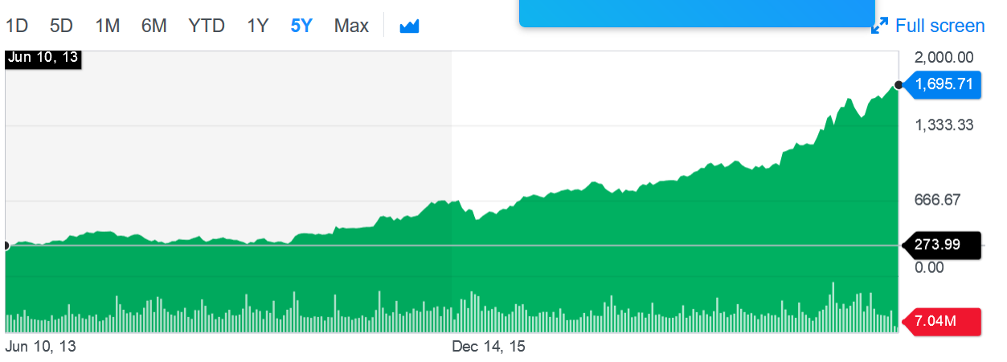
  - What is the five-year holding period return for Amazon?
  - What is the compound annual growth rate for Amazon over the last five years?
- Suppose a credit card charges an annual percentage rate (APR) equal to 15.24% per year.
  - What is the periodic monthly rate charged?
  - What is the corresponding effective annual rate (EAR)?
  - What is the continuously compounded interest corresponding to the EAR calculated in part b?
Fisher Equation
- If inflation is expected to be 2.5% and a lender demands a real return of 6%, what (minimum) nominal interest rate would she charge?
- If the interest rate is 4%, what is the value of a company that will earn profits in each of the next four years given by the following Excel table?
